S_P99_41000062 -

Functionality

This report is useful in the analysis of materials with regard to prices (for example, comparison of the standard price and the periodic unit price) or inventory values (analysis of the price and exchange rate differences of the ending inventory).

Scenario
This transaction can be used to analyze prices and inventory. You can select the currency/valuation used.

Requirements
Material ledger has been activated.

Menu Path | SAP menu → Accounting → Controlling → Product Cost Controlling → Actual Costing/Material Ledger → Information System → Object List → S_P99_41000062 - Prices and Inventory Values
Transaction Code | S_P99_41000062

1. Double Click on S_P99_41000062 - Prices and Inventory Values.

Material List: Prices and Inventory Values

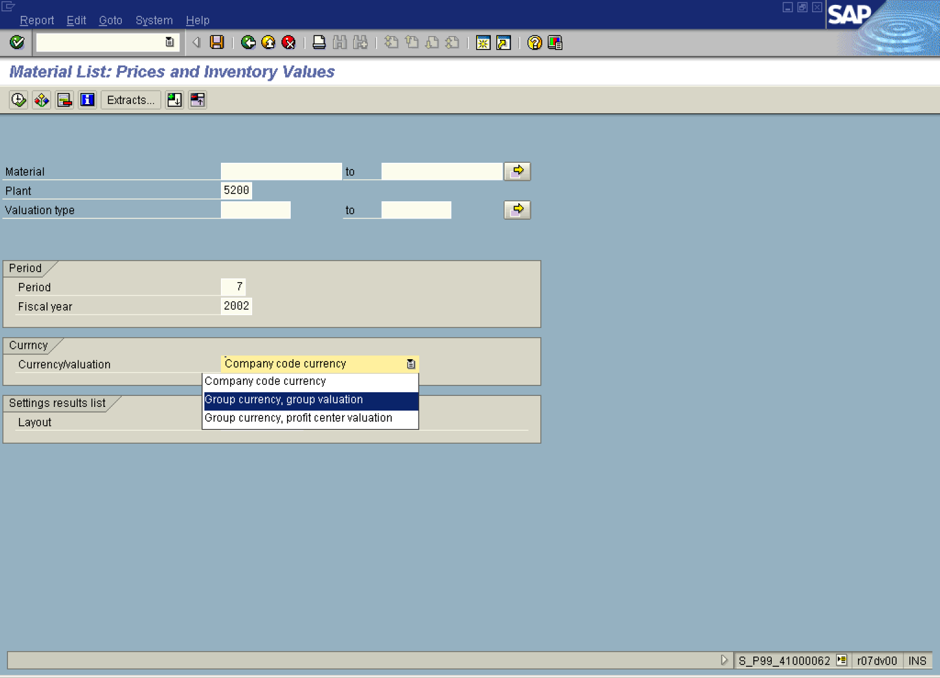

2. Update the following fields:

Field Name | Field Description | Values
Plant | Code identifying the operational unit of the company where the material is manufactured and stored | Example: 5200
Period | Enter relevant period | Example: 7
Fiscal year | Enter fiscal year | Example: 2002

3. Click Currency/valuation Button .

4. Select Group currency, group valuation in list box.
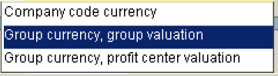

Material List: Prices and Inventory Values

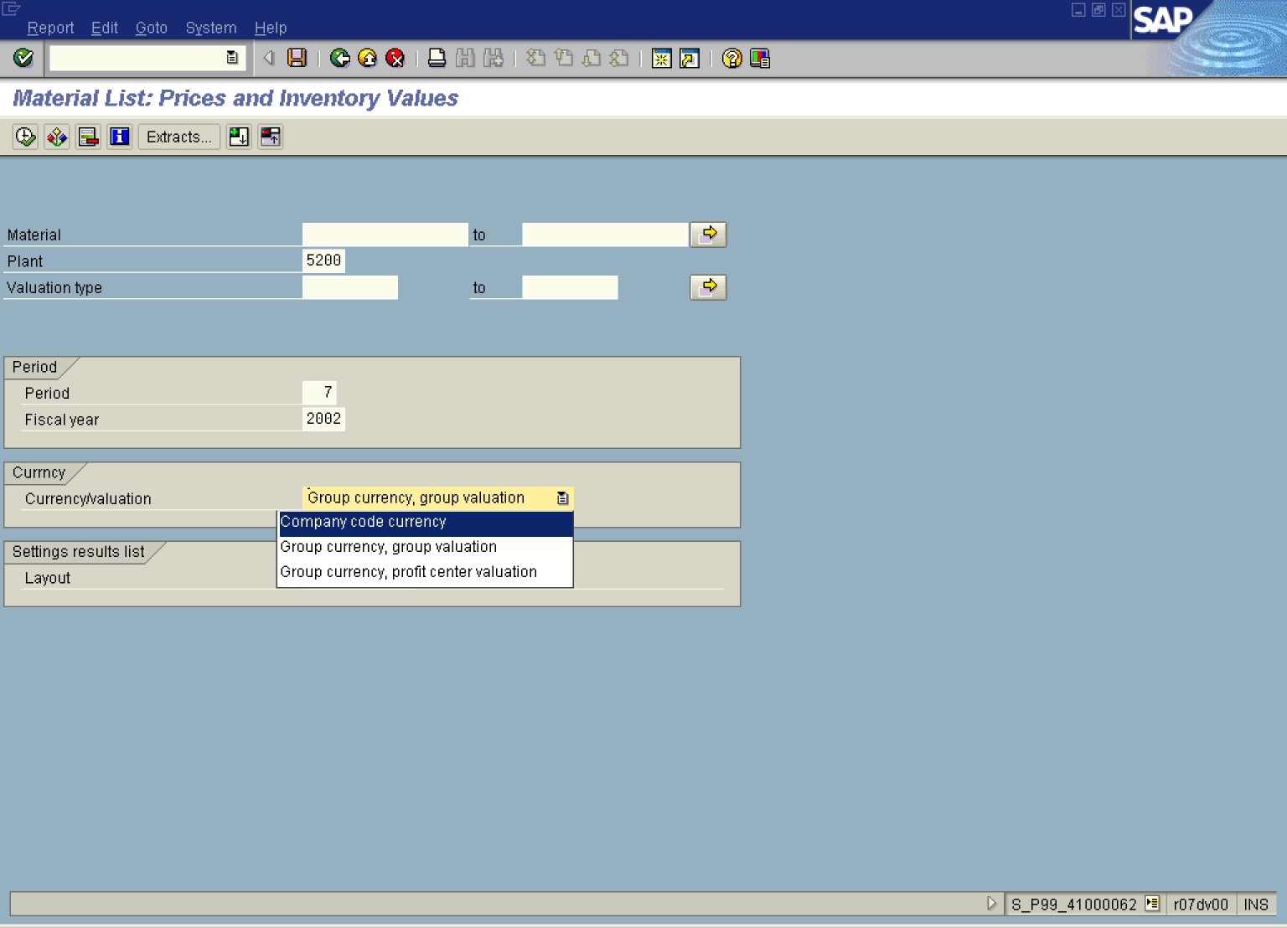

5. Click .

Material List: Prices and Inventory Values

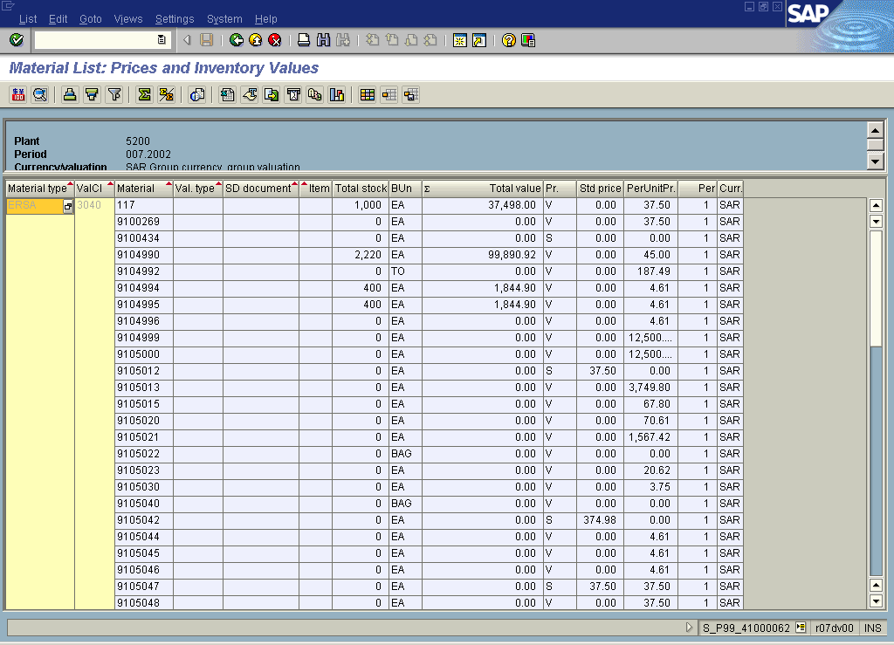

6. Click Back .

7. Click Currency/valuation Button .

8. Select Company code currency in list box.
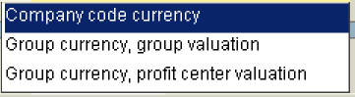

Material List: Prices and Inventory Values

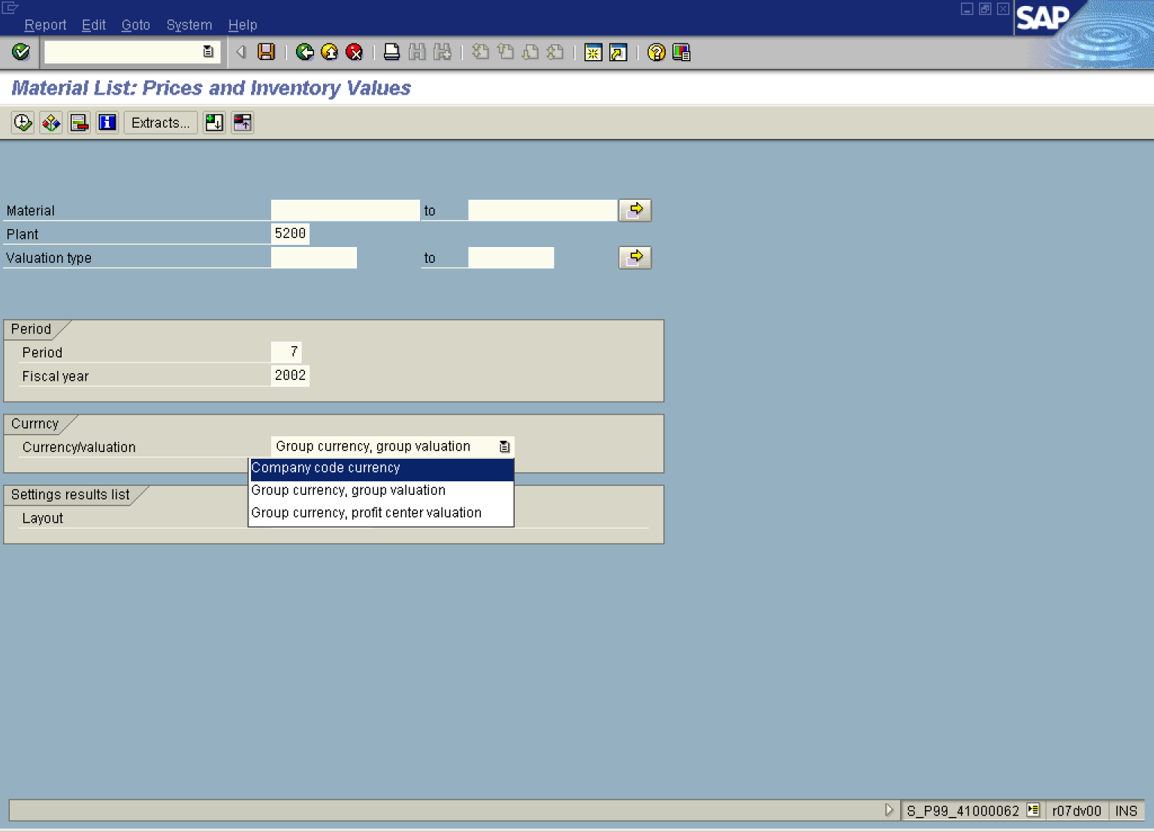

Material List: Prices and Inventory Values

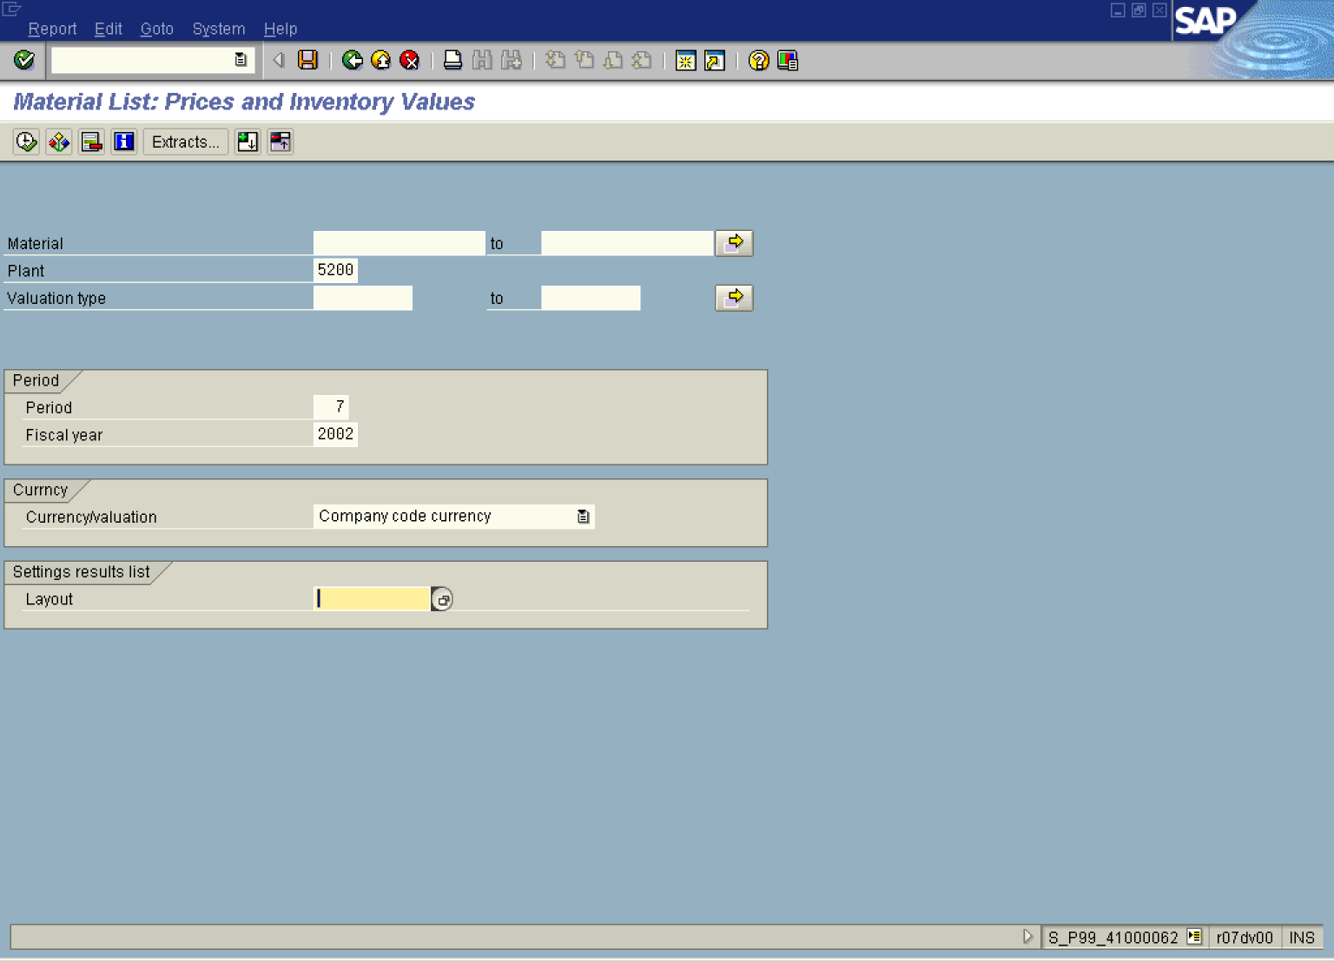

9. Click Layout .

Layout: Choose
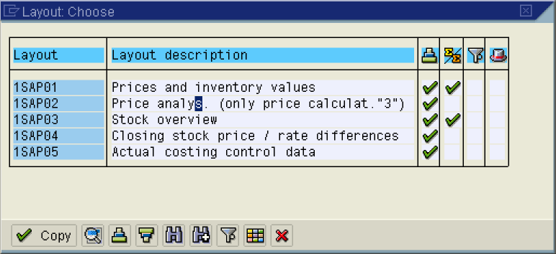

10. Click Price analys. (only price calculat."3") Button .

Material List: Prices and Inventory Values

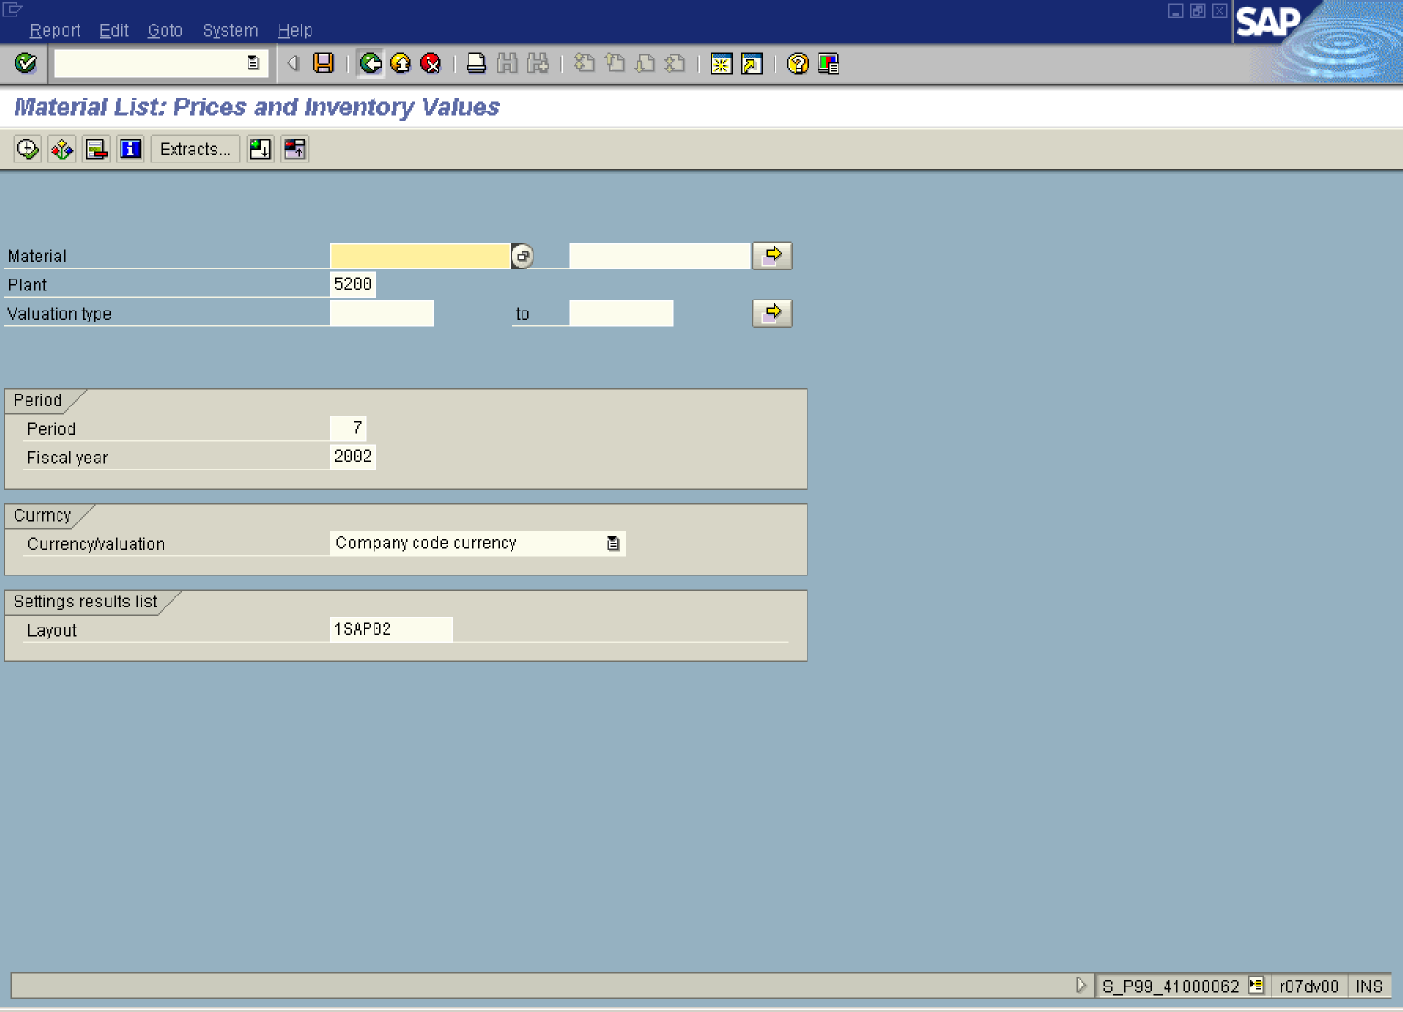

11. Click .

Material List: Prices and Inventory Values

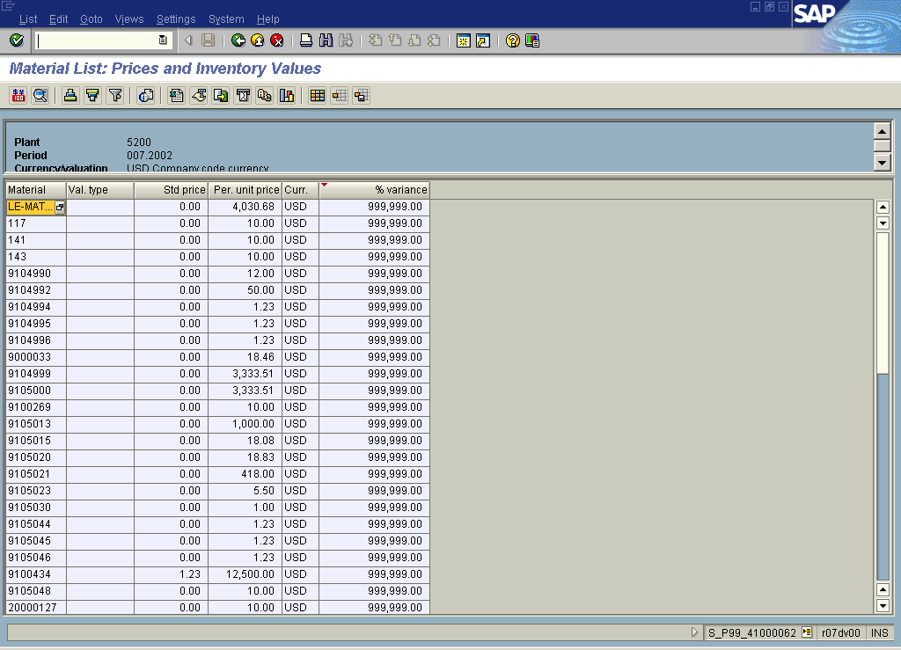

12. Click Back

